ACIT 3640 – Part 1
Setting Up AWS Student Accounts

- Do you already have an AWS account? You can use that account for this course.
- This YouTube video shows you how to set up an AWS Account: https://www.youtube.com/watch?v=WviHsoz8yHk
  - The screen shots are different, but the steps are the same.
  - Use your @my.bcit.ca email address.
  - When asked to select an AWS Service Plan, choose Basic (Free).
- Log back into aws.amazon.com to verify your account has been created.
- From you name in the top right corner, select My Account.
  - On left side, click “Payment Methods.”
  - Is your credit card there?
  - Write down your AWS Account ID.
    - From you name in the top right corner, select My Account.
    - Under Account Settings in the top of the screen is your Account ID.
- Apply for AWS Educate $100 USD credit.
  - Go to https://aws.amazon.com/education/awseducate/apply/
  - On the right, under Students, click “Apply for AWS Educate for Students.
  - In the first field, Institution Name, type “British Columbia…” until BCIT appears.
  - Enter your Email address – It must be your @my.bcit.ca email address.
  - Enter your AWS Account Id.
  - After you have created your AWS Educate account, you will receive an email from AWS. It will contain an AWS Promotional Credit Code.
- Once you receive the credit code, log into your AWS account.
  - Make sure you are logged into your aws.amazon.com account.
  - From you name in the top right corner, select My Account.
  - On the left hand side menu, click on Credits.
  - In the top field, paste the Promo Code from your email.
  - Enter the Security Check and click the Redeem button.
  - Your $100 USD credit should appear immediately below the Redeem button.
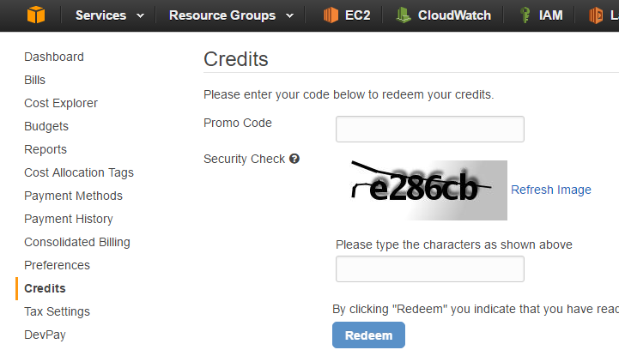

- That’s it! You should be good to go for the rest of our labs.

